|  |  |  |  |
| --- | --- | --- | --- |
| Name:  Class: | ____________________________________  ________________ | | Date:_________ |
|  | **Year 11 Essential Mathematics**  / 42    **Unit 1 Test 3 2019**  **Topic – Graphs** | | |
| **Total Time:** | 45 minutes |  | |
| **Weighting:** | 4% |
| **Equipment:** | To be provided by the student: Pen, pencil, ruler,1 A4 page of notes, scientific calculator | | |

**Full working out must be shown to get full marks. Attempt all questions.**

1. **[5 marks: 1,1,1,2]**

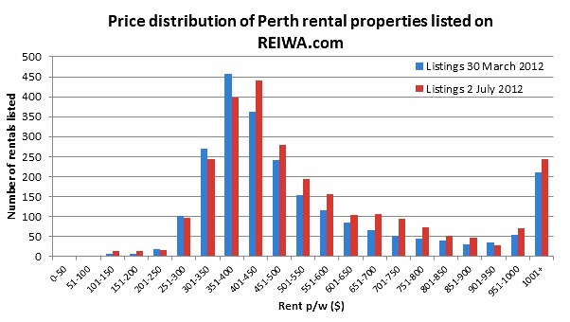

* 1. From the above graph what is the lowest rent per week?
  2. What is the highest rent per week?
  3. Which rent bracket has the most number of rentals?
  4. Explain why the $1001 + rent p/w column has a sharp increase compared to the previous columns.

1. **[10 marks: 7,1,1,1]**

56 children were asked which of the following hobbies they prefer. Their results are recorded in the table below.

|  |  |  |  |  |
| --- | --- | --- | --- | --- |
|  | Computer games | Watch Films | Read | Total |
| Girls | 5 |  |  | 22 |
| Boys |  | 11 |  |  |
| Total | 24 |  | 10 |  |

1. Complete the missing values
2. How many boys prefer computer games?
3. What percentage of children watched films?
4. What percentage of girls read books?
5. **[4 marks]**

Police recorded the average number of people caught drink driving on the same section of road on different nights of week.

|  |  |  |  |  |  |  |  |
| --- | --- | --- | --- | --- | --- | --- | --- |
| Monday | 5 | Tuesday | 6 | Wednesday | 4 | Thursday | 10 |
| Friday | 12 | Saturday | 17 | Sunday | 8 |  |  |

Represent the above information as a pictograph. Use a bottle to represent two people.

1. **[3 marks]**

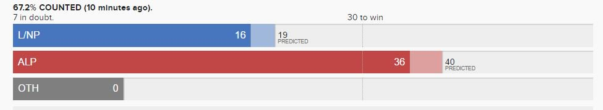

List 3 things that are missing or wrong with this graph.

1. **[6 marks]**

The following data set shows the temperatures over 1 day.

|  |  |  |  |  |  |  |  |  |  |
| --- | --- | --- | --- | --- | --- | --- | --- | --- | --- |
| **Time** | **Noon** | **3pm** | **6pm** | **9pm** | **Midnight** | **3am** | **6am** | **9am** | **noon** |
| **Temperature** | **30C** | **33C** | **30C** | **29C** | **25C** | **23C** | **22C** | **28C** | **32C** |

Draw an appropriate graph for this data

|  |  |  |  |  |  |  |  |  |  |  |  |  |  |  |  |  |  |  |  |
| --- | --- | --- | --- | --- | --- | --- | --- | --- | --- | --- | --- | --- | --- | --- | --- | --- | --- | --- | --- |
|  |  |  |  |  |  |  |  |  |  |  |  |  |  |  |  |  |  |  |  |
|  |  |  |  |  |  |  |  |  |  |  |  |  |  |  |  |  |  |  |  |
|  |  |  |  |  |  |  |  |  |  |  |  |  |  |  |  |  |  |  |  |
|  |  |  |  |  |  |  |  |  |  |  |  |  |  |  |  |  |  |  |  |
|  |  |  |  |  |  |  |  |  |  |  |  |  |  |  |  |  |  |  |  |
|  |  |  |  |  |  |  |  |  |  |  |  |  |  |  |  |  |  |  |  |
|  |  |  |  |  |  |  |  |  |  |  |  |  |  |  |  |  |  |  |  |
|  |  |  |  |  |  |  |  |  |  |  |  |  |  |  |  |  |  |  |  |
|  |  |  |  |  |  |  |  |  |  |  |  |  |  |  |  |  |  |  |  |
|  |  |  |  |  |  |  |  |  |  |  |  |  |  |  |  |  |  |  |  |
|  |  |  |  |  |  |  |  |  |  |  |  |  |  |  |  |  |  |  |  |
|  |  |  |  |  |  |  |  |  |  |  |  |  |  |  |  |  |  |  |  |
|  |  |  |  |  |  |  |  |  |  |  |  |  |  |  |  |  |  |  |  |
|  |  |  |  |  |  |  |  |  |  |  |  |  |  |  |  |  |  |  |  |
|  |  |  |  |  |  |  |  |  |  |  |  |  |  |  |  |  |  |  |  |
|  |  |  |  |  |  |  |  |  |  |  |  |  |  |  |  |  |  |  |  |
|  |  |  |  |  |  |  |  |  |  |  |  |  |  |  |  |  |  |  |  |
|  |  |  |  |  |  |  |  |  |  |  |  |  |  |  |  |  |  |  |  |
|  |  |  |  |  |  |  |  |  |  |  |  |  |  |  |  |  |  |  |  |
|  |  |  |  |  |  |  |  |  |  |  |  |  |  |  |  |  |  |  |  |

1. **[6 marks]**

Suggest which data display or graph would be best for each data set and give your reason

|  |  |  |
| --- | --- | --- |
| Data | Display/graph | Reason |
| The percentage of students in each year group at school |  |  |
| The price of fuel over a week |  |  |
| The favourite chocolate bars of students at school |  |  |

1. **[8 marks: 1,1,2,2,2]**

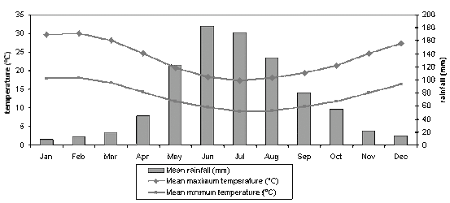

* 1. What is the mean maximum temperature in September?
  2. Which month has the coldest mean minimum temperature?
  3. What is the difference between the mean maximum and mean minimum temperatures in May?
  4. How much more rain falls in June than December?
  5. Describe the annual rainfall pattern?